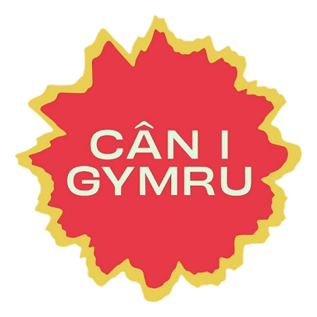

CÂN I GYMRU 2027
APPLICATION FORM

Thank you for expressing your interest in Cân i Gymru 2027 and for submitting your original song

Before submitting your application, please read each of the following declarations carefully. By ticking the boxes below, you confirm that you have read, understood and agree to the competition requirements and eligibility conditions for Cân i Gymru 2027.
Failure to comply with these requirements may result in your application being deemed ineligible.

Declaration 1
☐ I confirm that the song is my own original work and has not been created or materially assisted using artificial intelligence (AI) tools.

Declaration 2
☐ I understand that, if my song is shortlisted, the production company will work collaboratively with me as the composer to identify the most suitable performer(s) to present the song. This may be the composer performing the song themselves or guest performer(s), at the discretion of, and with the final decision resting with, the production company and S4C.

Declaration 3
☐ I also understand that only one song per composer may progress to the Final Eight.

APPLICATION DETAILS

NAME:

ADDRESS:

HOME PHONE NUMBER:

MOBILE PHONE NUMBER:

E-MAIL:

DATE OF BIRTH:

SONG NAME:

LYRICS:

COMPOSER:

A SUGGESTION OF WHO YOU WOULD LIKE TO PERFORM THE SONG:

Please read the competition rules before going any further.
For a copy of the rules please go to s4c.cymru/canigymru

Tick here to confirm that you have read, understood and agree with the terms of the competition
CD / MP3

Copy of the lyrics on paper or Word Document
Send in your application form and song before 23:59 on Sunday the 4th of October 2026.

Post:  Cystadleuaeth Can i Gymru 2026,  Afanti Media Limited,  Uned 2 & 3, Ffordd Dowlais, Caerdydd, CF24 5TW |  | E-mail:  canigymru@afantimedia.tv

